AI Use Declaration Form
Course: Introduction to Artificial Intelligence
Lab Title: Lab 1 Part A — Uninformed Search Algorithms
Student Name: Mariam Goge Kessa
Student ID: 30682027
GitHub Repository Link: https://github.com/mariam-kessa123/Lab1_Uninformed_and_Informed_Search_Algorithms.git
Date Submitted: 20/6/2026

1. AI Use Summary
Question | Student Response
Did you use any AI tool for this lab? | yes
Estimated percentage of the work influenced by AI | 25 %
Did you attach evidence of AI use where applicable? | yes

2. Details of AI Use
Complete the table below for each AI tool used. Add more rows where necessary.
Name of AI Tool Used | Purpose for Using the Tool | Prompt or Instruction Given to the Tool | Part(s) of the Work Influenced by the Tool | How I Verified, Edited, or Improved the AI Output
Copilot | Error explanation | explain this error :IndexError Traceback (most recent call last) /tmp/ipykernel_7612/3329720467.py in <cell line: 0>() 34 35 custom_results_1 = [ ---> 36 ucs.search(custom_problem_1), 37 astar.search(custom_problem_1), 38 wastar2.search(custom_problem_1),  2 frames /tmp/ipykernel_7612/770097467.py in search(self, problem) 73 # d. for each child in self.expand(problem, node): 74 ---> 75 for child in self.expand(problem, node): 76 s = child.state 77 if s not in reached or child.path_cost < reached[s].path_cost:  /tmp/ipykernel_7612/1433483820.py in expand(self, problem, node) 10 for action in problem.actions(s): 11 s_prime = problem.result(s, action) ---> 12 cost = node.path_cost + problem.action_cost(s, action, s_prime) 13 yield Node(state=s_prime, parent=node, action=action, path_cost=cost) 14  /tmp/ipykernel_7612/398515838.py in action_cost(self, state, action, next_state) 33 # Steps: 34 row, col = next_state ---> 35 return self.terrain_costs[row][col] 36  IndexError: list index out of range | #15. Create Your Own Maps | I followed the explanation and figured out what to do next
 |  | I have been on my notebook assignment about the informed search problems, but this is error I am getting:AssertionError Traceback (most recent call last) /tmp/ipykernel_12233/946900475.py in <cell line: 0>() 15 ]: 16 res = algo.search(check_problem) ---> 17 assert res.status == "success", f"{res.algorithm} failed to find a path" 18 assert res.solution_cost == 4, f"{res.algorithm} returned cost {res.solution_cost}, expected 4" 19 assert res.path[0] == (0, 0) and res.path[-1] == (2, 2) AssertionError: Greedy failed to find a path | #7. Greedy Best-First Search
 |  | explain this error:UnboundLocalError Traceback (most recent call last) /tmp/ipykernel_2207/965624371.py in <cell line: 0>() 10 dfs.search(problem), 11 dls.search(problem, limit=10), ---> 12 ids.search(problem, max_depth=30), 13 ] 14  /tmp/ipykernel_2207/999466446.py in search(self, problem, max_depth) 30 31 total_nodes_expanded += result.nodes_expanded ---> 32 max_stack_size = max(max_stack_size, result.max_frontier_size) 33 34 iteration_log.append(limit, result.status)  UnboundLocalError: cannot access local variable 'max_stack_size' where it is not associated with a value | 13. Run the Algorithms on the Sample Map

3. Attachment of AI Output Evidence
Where required, attach evidence of AI use. Tick all that apply. Add more rows where necessary.

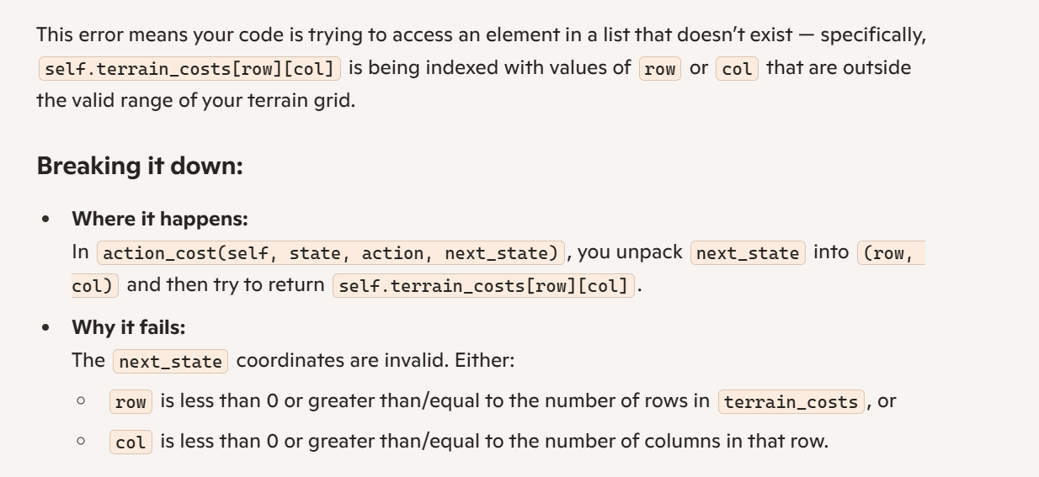
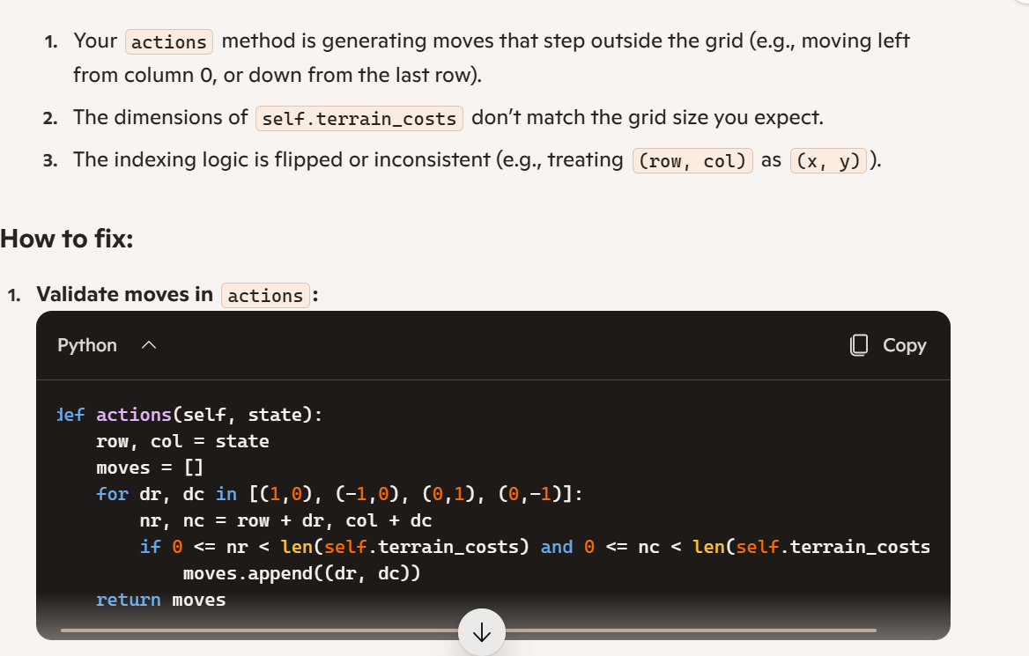

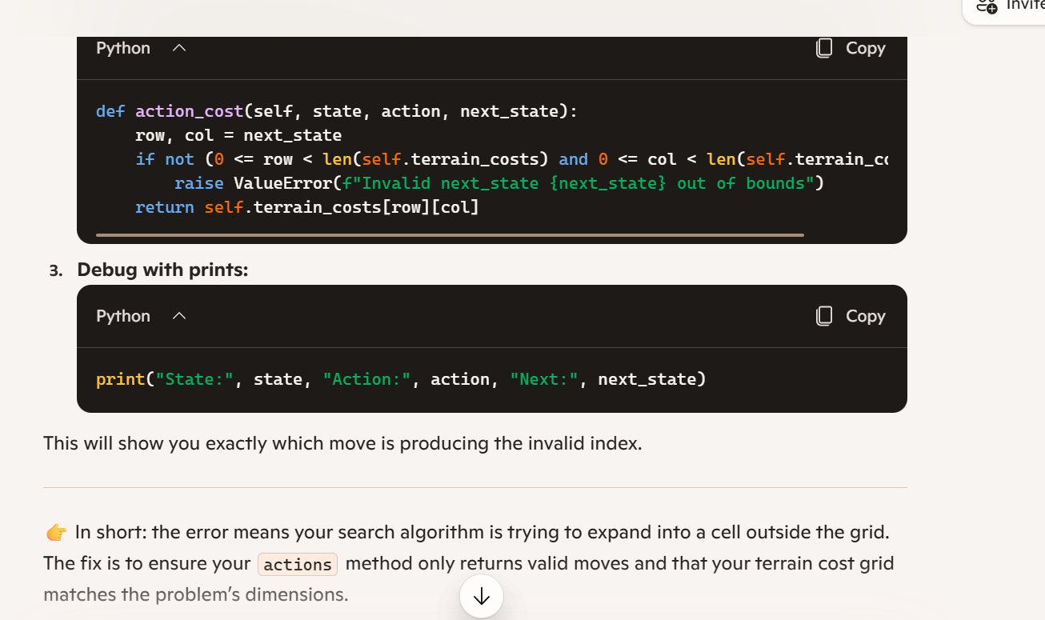

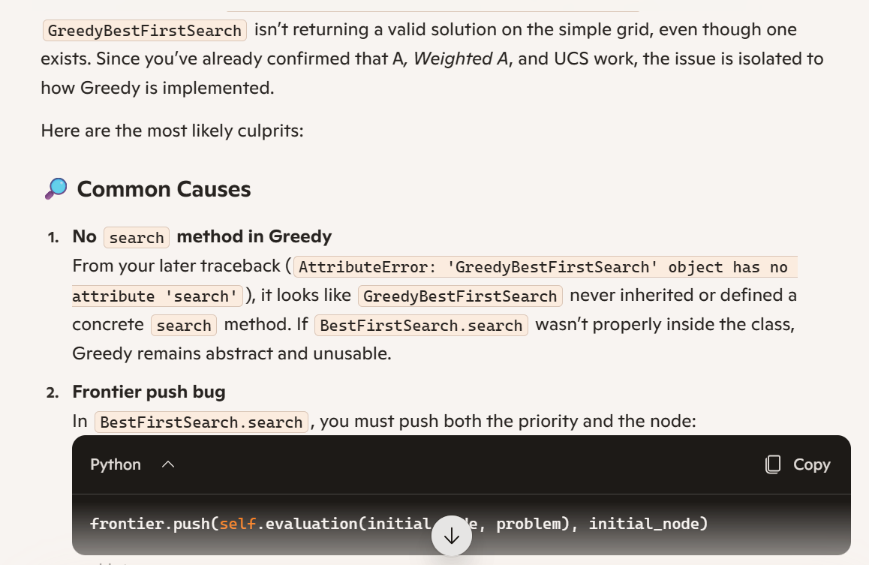

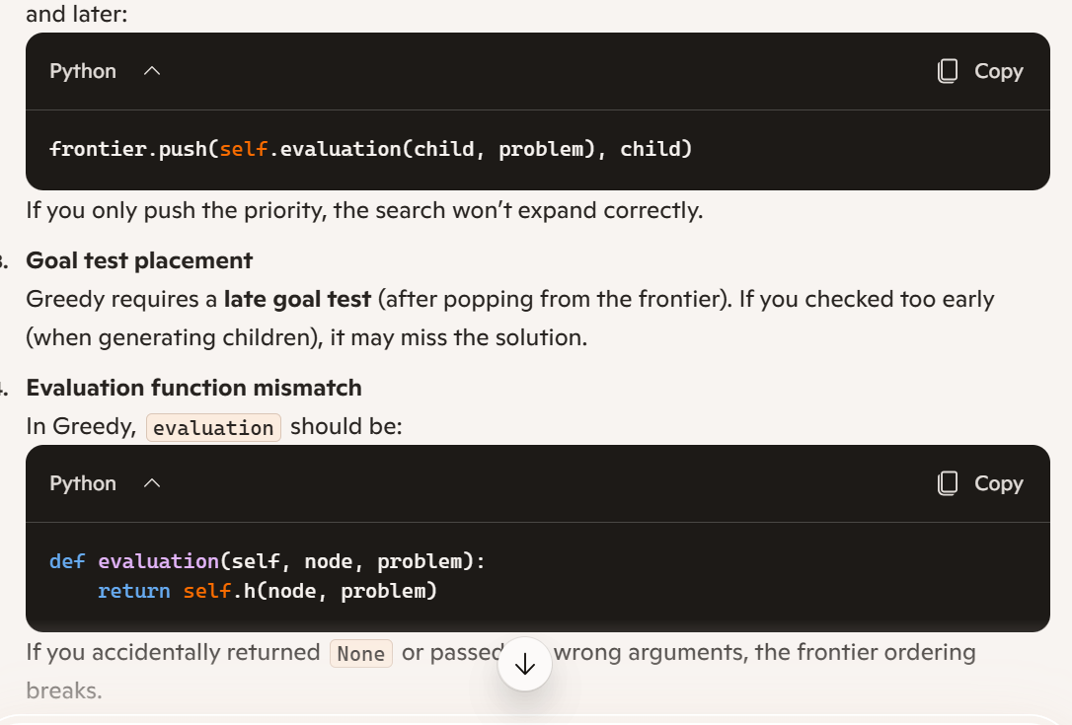

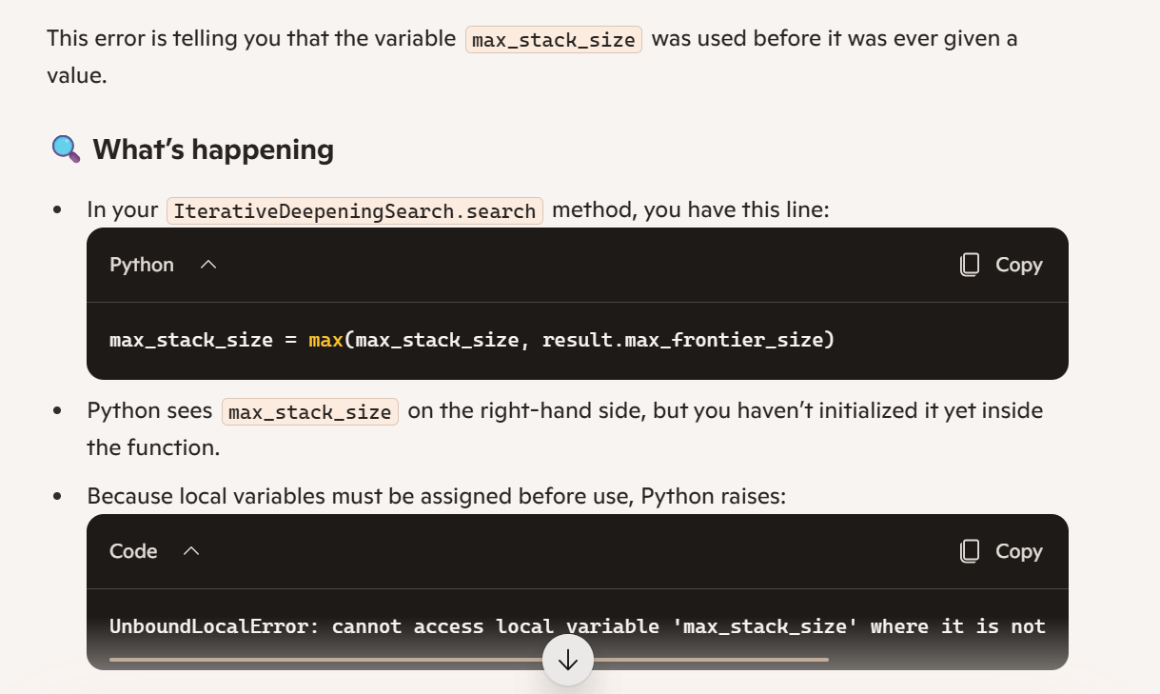

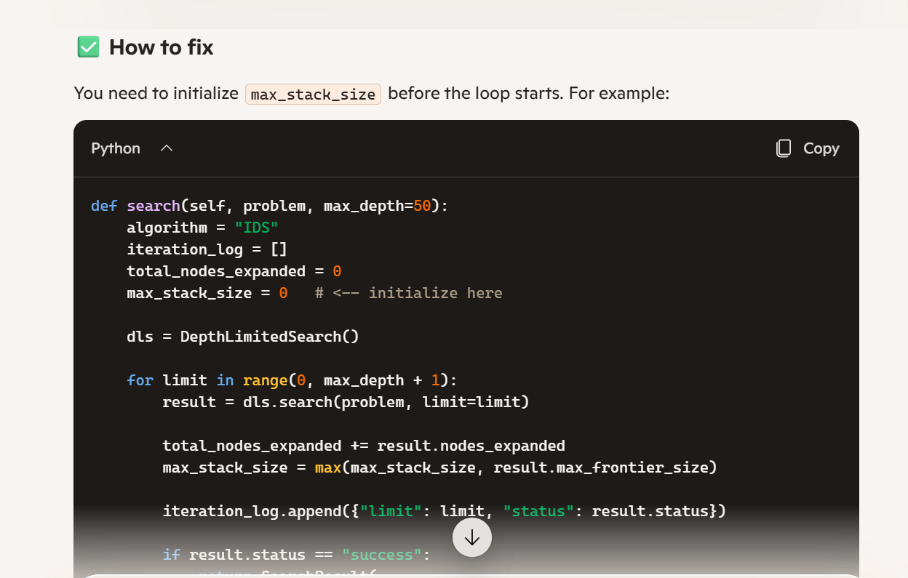

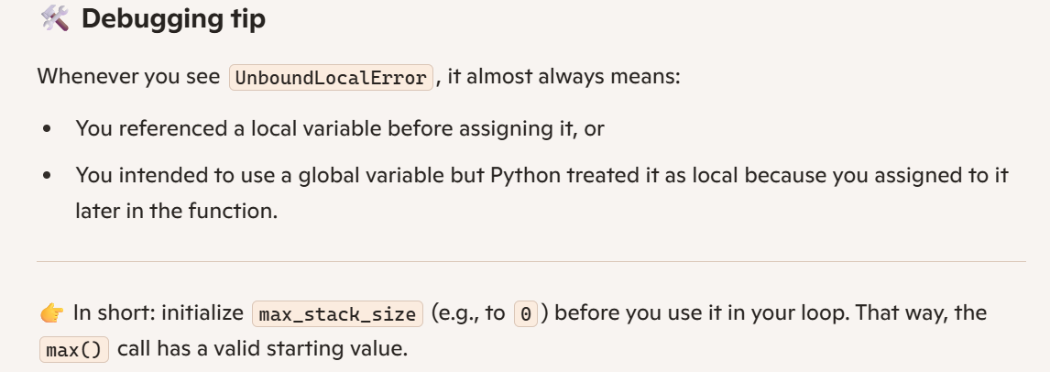

Evidence Type | Attached? (Yes, No, N/A) | File Name
AI-generated draft | yes | Screenshot
Prompt history | yes
Screenshot of AI interaction | yes
Exported AI conversation | yes
AI-generated code snippet | yes
Revised version showing student input

4. Student Declaration
I declare that:
Declaration Statement | Response (Yes/No)
The submitted work is my own work. | Not fully but the larger part of it.
Any use of AI tools has been clearly declared in this form. | yes
The prompts, instructions, and AI-generated outputs have been disclosed where applicable. | yes
I reviewed, tested, edited, and improved any AI-generated content before submission. | yes
My AI usage does not exceed 25% of the entire work. | yes
I understand that undeclared or excessive AI use may be treated as academic misconduct. | yes

Student Signature: MGK
Date: 20/06/2026

